
FURTHER MATHEMATICS
TRIAL EXAMINATION 2
SOLUTIONS
2011

SECTION A

Core - solutions

Question 1

- 9C has 14 students with a concession card.
Four classes have more than this (8C, 9B, 9D and 10A).
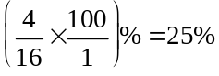
(1 mark)

- The circled value is 19 so 8C is represented by this value.
(1 mark)

- Using the ordered stemplot, the 8th value is 7 and the 9th value is 9. The median is 8.
(1 mark)

- The shape is positively skewed.
(1 mark)

- The median is a better measure of the centre of the distribution because the shape of the distribution is skewed.
(1 mark)

Question 2

(correct to 2 decimal places)
(1 mark)
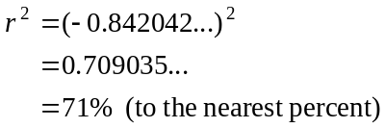

So 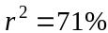 (to the nearest percent)
So 71% of the variation in the number of times a student is late to school can be explained by the variation in the distance between their home and school.
(1 mark)

- Use your calculator to find this

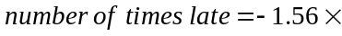 distance + 13.04
(1 mark) for – 1.56
(1 mark) for 13.04
- Using part c,
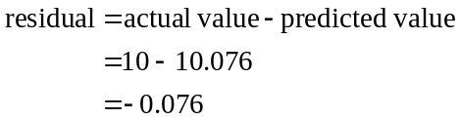
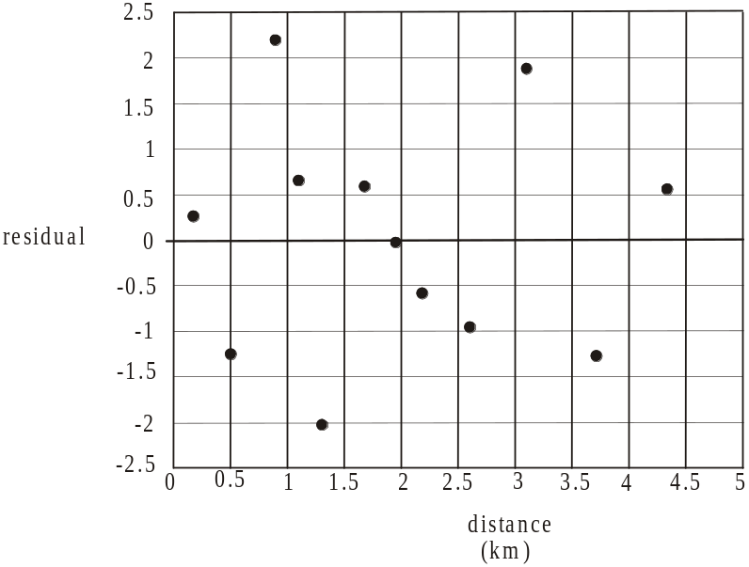

(1 mark)
- The residual plot shows a collection of points scattered randomly around the horizontal line with a residual of zero; i.e. there is no clear pattern and hence the assumption of linearity is supported.
(1 mark)
Question 3
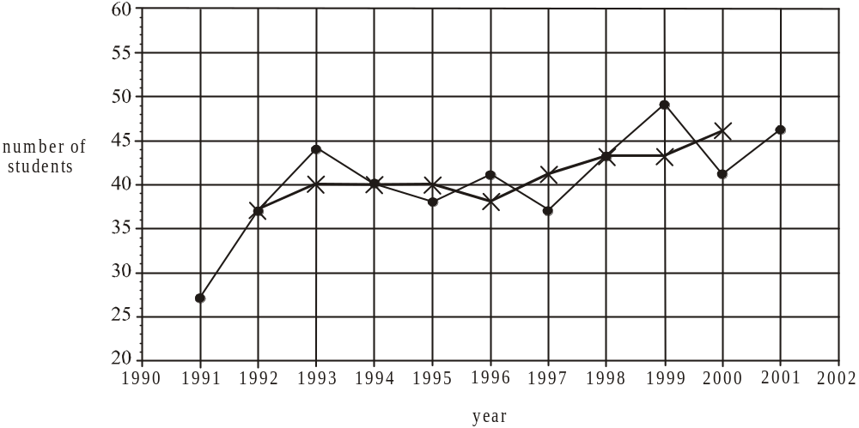

(1 mark) 4 correctly placed crosses
(1 mark) correct smoothed time series plot
- The year 2010 is referred to as year number 20.
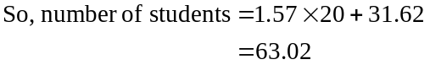
Predicted number of students is 63 (correct to nearest whole number). (1 mark)
- Average, annual increase is 1.57 or 2 (correct to nearest whole number).
(1 mark)
Total 15 marks
SECTION B

Module 1: Number patterns

Question 1

- 55, 100, 145, 190,…
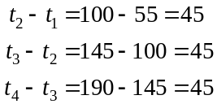
There is a common difference of 45 between successive terms so the sequence is arithmetic.
(1 mark)

- Method 1 – using a calculator
Generate the sequence. The 15th term is 685.
(1 mark)

Method 2 – by hand
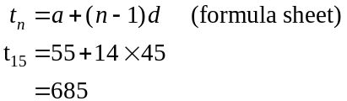
(1 mark)

- Method 1 – using a calculator
Generate the sequence. The 29th term is $1315 and the 30th term is $1360.
Keisha can purchase a maximum of 29 tickets.
(1 mark)
Method 2 – by hand
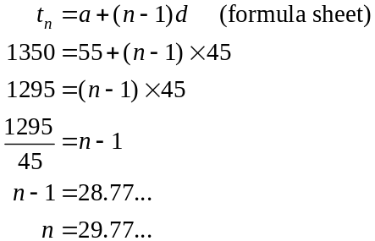
Keisha can purchase a maximum of 29 tickets.
(1 mark)

- The difference equation defines an arithmetic sequence so .

(1 mark) for 1
(1 mark) for 45

Question 2

- Method 1 – using a calculator
Generate the sequence.
65, 58.5, 52.65, 47.39, 42.65…
The cost of the 5th ticket is $42.65.
(1 mark)
Method 2 – by hand
The sequence is geometric so
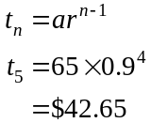
(1 mark)
- Method 1 – using a calculator
Generate the sequence.
The 12th term is 20.40.
The 13th term is 18.36.
So 13 tickets must be purchased before the cost of a ticket drops below $20.
(1 mark)
Method 2 – using CAS
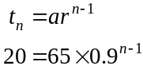
Solve for n. So n = 12.1869.
So 13 tickets must be purchased before the cost drops below $20.
(1 mark)
- The sequence is a decreasing geometric sequence (i.e. r < 1) so
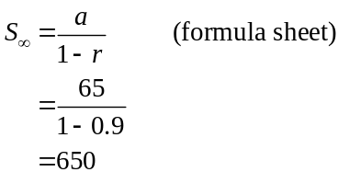
The maximum amount that can be spent is $650.
(1 mark)
- From Ticketget, we need to find the 8th term of the arithmetic sequence because the n^{th} term gives us the cost of purchasing n tickets.
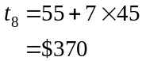
(1 mark)
From Dodgeybros, we need to find the sum of the first 8 terms since the n^{th} term gives us the cost of the n^{th} ticket.
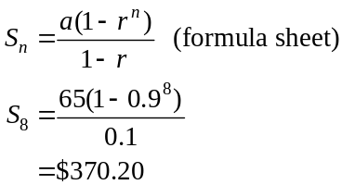
So Keisha saves $0.20 by purchasing from the Ticketget website.
(1 mark)
e. The cost of each ticket on the Ticketget website is $45. On the Dodgeybros website the cost of the 9th ticket is 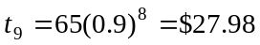.
The cost of subsequent tickets is now cheaper with Dodgeybros so Keisha should purchase them from the Dodgeybros website. (1 mark)
Question 3

- Method 1 – using a calculator
Generate the sequence.
4200, 4204, 4208.08, 4212.24
The number of tickets predicted to be sold in the fourth month is 4212.
(1 mark)
Method 2 – by hand
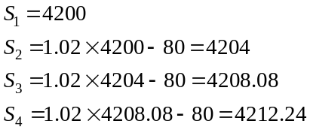
The number of tickets predicted to be sold in the fourth month is 4212.
(1 mark)
- Using the results from either method in part a.,
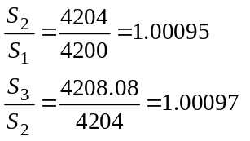
Since 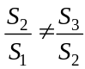the sequence does not have a common ratio and is therefore not geometric.
(1 mark)
- Method 1 – using a calculator
Generate the sequence.
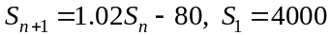
4000, 4000, 4000,…
The monthly sales remain on 4000 so there is no growth. (1 mark)
Generate the sequence.
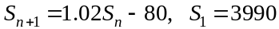
(i.e. choose a value less than 4000)
3990, 3989.8, 3989.6, …
The monthly sales are decreasing so there is no growth.
(1 mark)
Method 2 – by hand
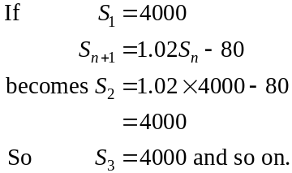
The monthly sales remain on 4000 so there is no growth. (1 mark)
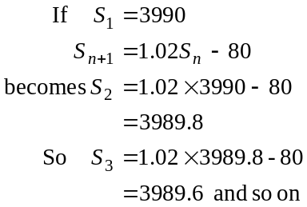
The monthly sales are deceasing so there is no growth. (1 mark)
Total 15 marks

Module 2: Geometry and trigonometry

Question 1
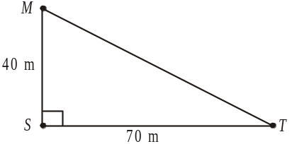

- In ,
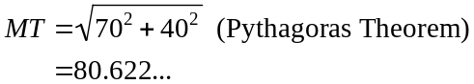
The distance is 80.6m correct to 1 decimal place.

(1 mark)

- In ,
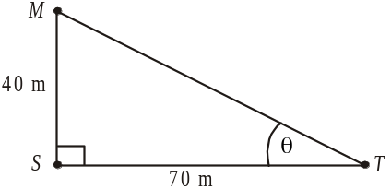
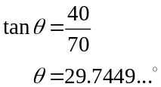
So 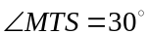 to the nearest whole degree.

(1 mark)

- The bearing of M from T is 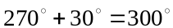.
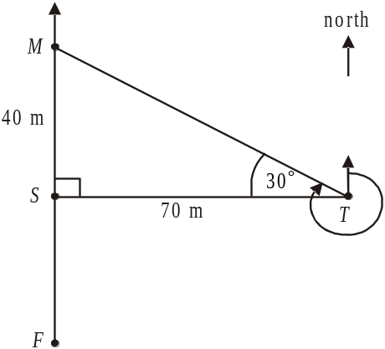

(1 mark)
- Since the bearing of F from T is 230°, 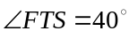. (1 mark)

So in ,
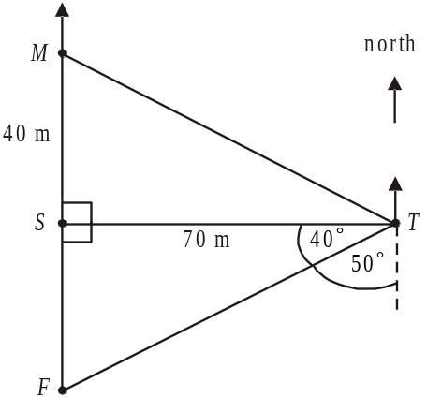
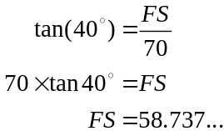
The distance from F to S is 58.7m correct
to 1 decimal place.

(1 mark)

Question 2
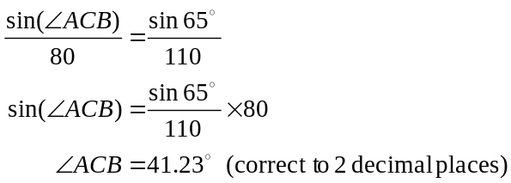

(1 mark)

- Since 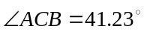,
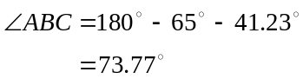
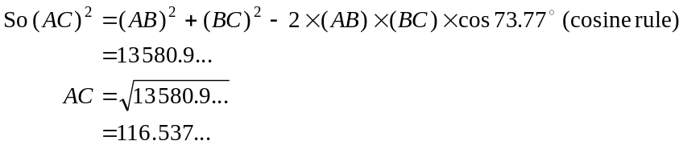
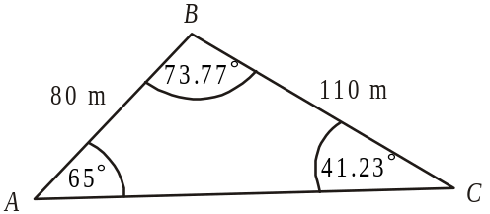
So 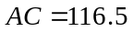m (correct to 1 decimal place).

(1 mark)
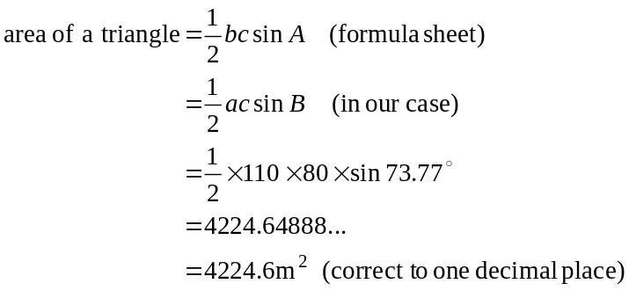

(1 mark)
- Use similar triangles.
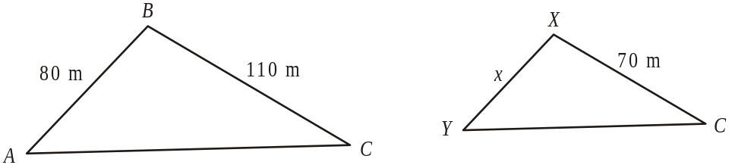

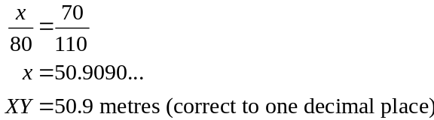

(1 mark) an attempt using similar triangles
(1 mark) correct answer

Question 3

Volume of prism = area of cross-section length
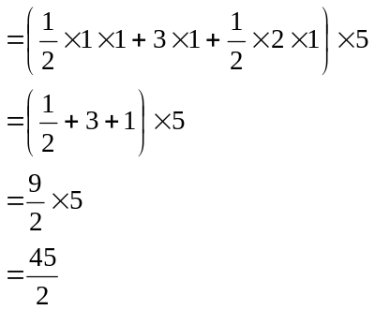
So 22.5 cubic metres of cement is required.
(1 mark) – attempt to find area of cross-section
(1 mark) – correct answer

Question 4
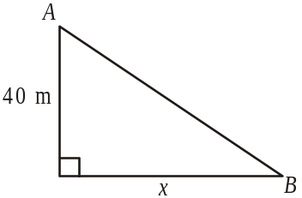
- The horizontal distance between the towers
(marked as x in the diagrams to the right) is equal.
From the contour lines, point A is 40m vertically
above point B and point B is 30m vertically above
point C.
Since gradient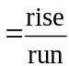, the section of cable between
A and B has the steeper gradient.
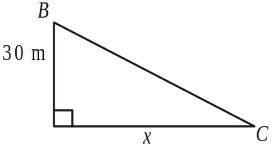
(1 mark)

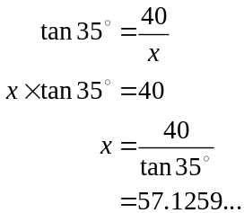
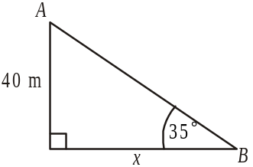

(1 mark)
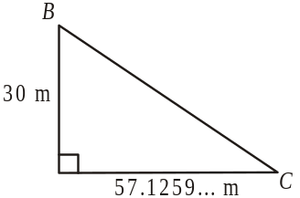

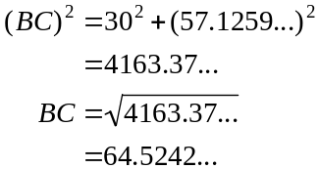
So the length of cable is 64.5m (correct to one decimal place).
(1 mark)
Total 15 marks
Module 3: Graphs and relations

Question 1

- 6.1m
(1 mark)

- 6pm
(1 mark)

- Between 12pm and 8pm the height of the river was increasing.
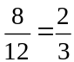
The height of the river was increasing for of the 12 hour period. (1 mark)

- 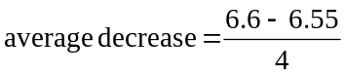
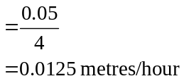
(1 mark)

Question 2

(1 mark)

- 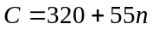
At break-even,
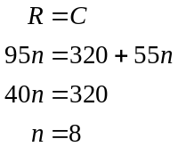
(1 mark)

- When 15 cabins are occupied,
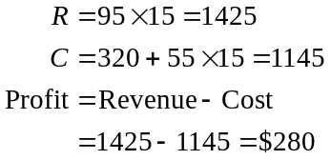
(1 mark)
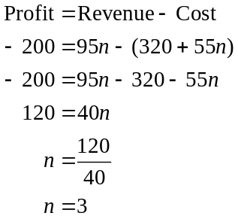

(1 mark)

Question 3

- The inequality 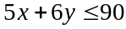 tells us that for every on-site-van that is rented overnight a maximum of 6 people can stay in it.
(1 mark)
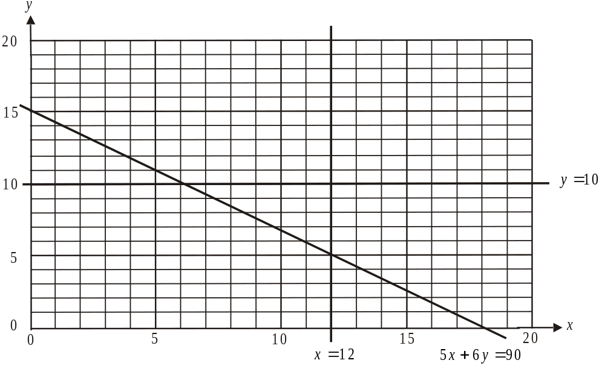

(1 mark)

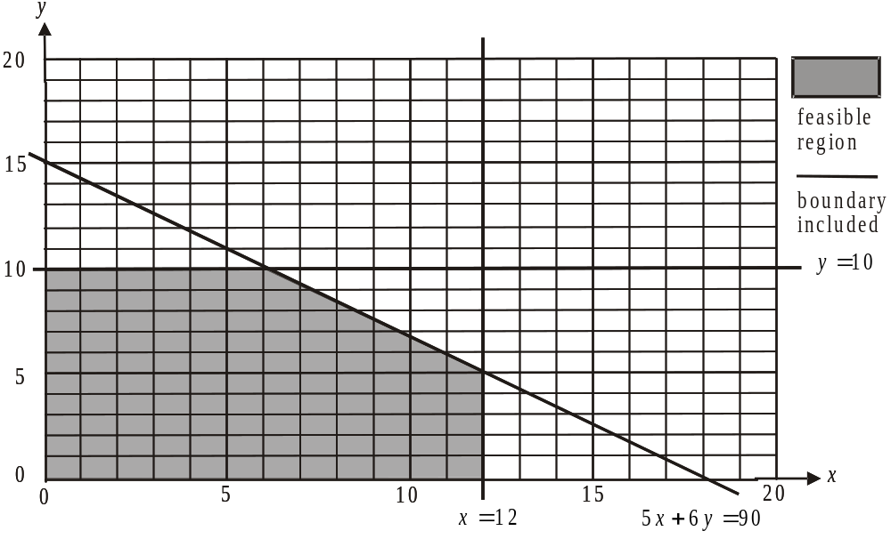

(1 mark)

- 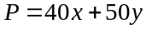
(1 mark)
From the graph, the corner points of the feasible region are

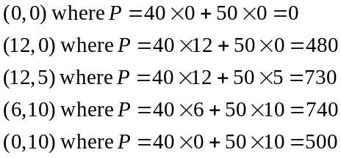

The maximum profit is $740.
(1 mark)

- The inequality is replaced with 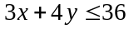. The revised feasible region is shown below.
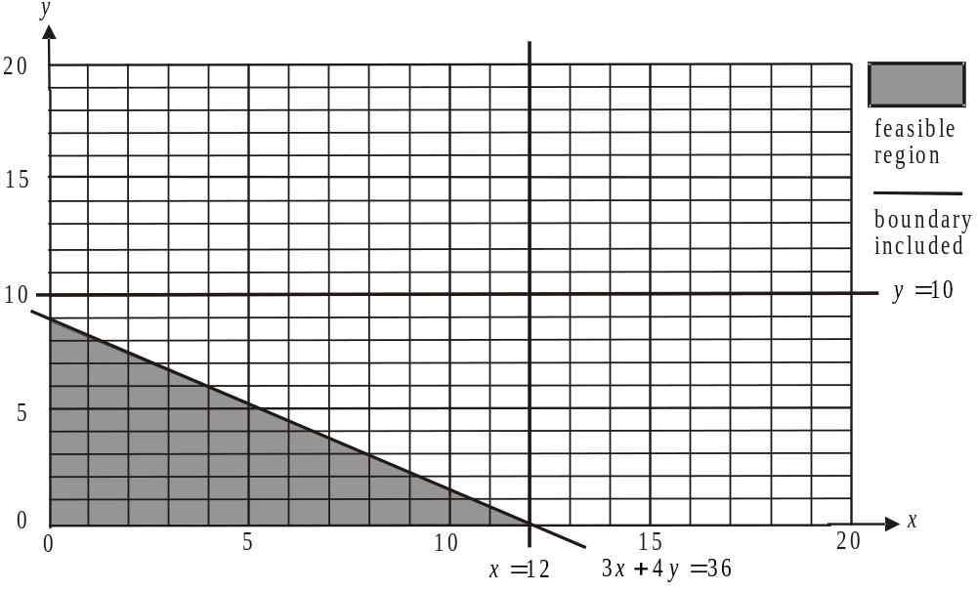

From part d., .
From the graph above, the corner points of the feasible region are

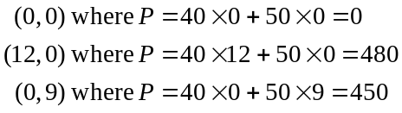

The maximum profit now possible is $480.
(1 mark) – correct corner points
(1 mark) – correct answer
Total 15 marks
Module 4: Business-related mathematics

Question 1
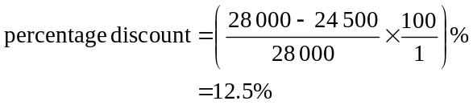

(1 mark)

- 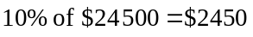
(1 mark)

Question 2

- 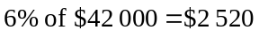
After 5 years its book value
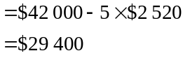
(1 mark)

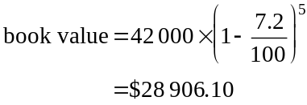

(1 mark)
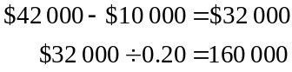

It will have been driven 160 000km.
(1 mark)

Question 3
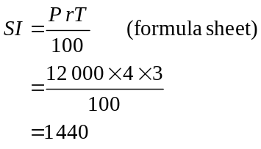

The investment is worth 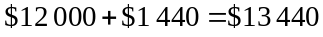 after 3 years.
(1 mark)
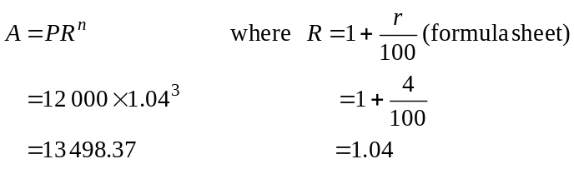

The investment is worth $13 498.37 after 3 years. (1 mark)
    - The interest needs to be calculated over a shorter period of time; for example, quarterly or monthly or weekly in order to add to the value of the investment.
(1 mark)
For example, if interest is calculated quarterly,
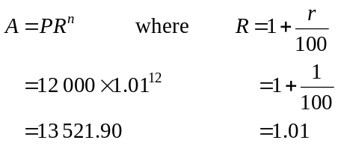
This amount is greater than 13 498.37 which was found in part b. (1 mark)

Question 4

- Use TVM
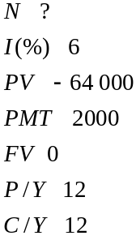
The annuity lasts for 35 months (to the nearest whole month). (1 mark)
- Use TVM – where 5 years is 60 months
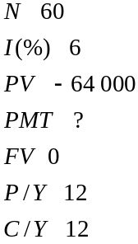
The monthly payment would be $1237.30. (1 mark)
Question 5

- Use TVM
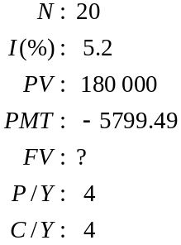
After 5 years the principal still owed is $101 560.35.
(1 mark)

- Use TVM.
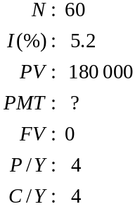
The quarterly payment will be $4339.09.
(1 mark)

- Over 10 years, the amount paid back is 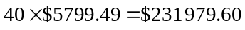
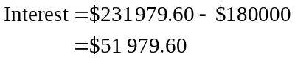
(1 mark)
Over 15 years, the amount paid back is 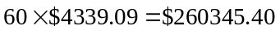
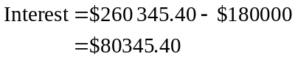
The couple will save
(1 mark)
Total 15 marks
Module 5: Networks and decision mathematics

Question 1

- Shortest route is 1050 metres.
(1 mark)

- A B C D E H F G I
or A B C G F D E H I
or A D C B G F E H I
There are others. A Hamiltonian path starts at one vertex, finishes at another and passes through all the other vertices just once.
(1 mark)

- The vertices that have an odd degree are A and I (which are the start and end points of the path) and E and H. The path between E and H needs to be removed.
(1 mark)

- We are looking for a minimal spanning tree.
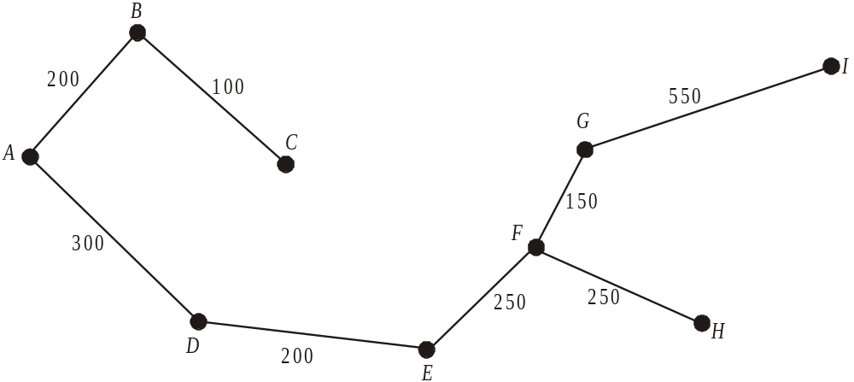

(1 mark)

Question 2

- There are no paths that leave a performing area and return to the same performing area, that is, there are no loops.
(1 mark)

- 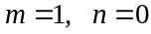
(1 mark)

Question 3

 | Performing area
 | B | C | D | E
Kev | 15 | 3 | 15 | 0
Pete | 10 | 0 | 13 | 0
Lucy | 20 | 0 | 10 | 2
Kiran | 22 | 4 | 14 | 0
Step 1 -Subtract from each element in a row, the minimum value for that row.
(1 mark)

- Step 2 – Repeat this process to columns B and D which have no zeros.
 | Performing area
 | B | C | D | E
Kev | 5 | 3 | 5 | 0
Pete | 0 | 0 | 3 | 0
Lucy | 10 | 0 | 0 | 2
Kiran | 12 | 4 | 4 | 0

Step 3 – Cover the zeros with as few lines as possible, in this case 3 (ie cover column
E and Pete and Lucy’s rows).

Step 4 – The minimum uncovered entry is 3.
Add this to the covered rows and columns.
 | Performing area
 | B | C | D | E
Kev | 5 | 3 | 5 | 3
Pete | 3 | 3 | 6 | 6
Lucy | 13 | 3 | 3 | 8
Kiran | 12 | 4 | 4 | 3

Step 5 – Subtract 3 from all entries.
Cover all zeros with as few lines as possible, in this case 4.
 | Performing area
 | B | C | D | E
Kev | 2 | 0 | 2 | 0
Pete | 0 | 0 | 3 | 3
Lucy | 10 | 0 | 0 | 5
Kiran | 9 | 1 | 1 | 0
(1 mark)
Because we needed 4 lines to cover all the zeros, we can now allocate.
Kiran can only be allocated to performing area E.
(1 mark)

Question 4

The network described by the table is given below.

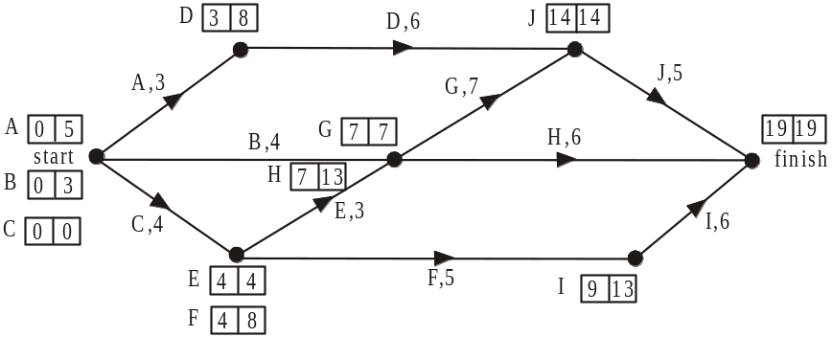

Note that A, B and C have no immediate predecessors so they appear at the start and H, I and J are not immediate predecessors to any activities so they appear at the finish.
The EST and LST for each activity is shown for each activity.

- The EST for activity G is 7 days.
(1 mark)

- The LST for activity H is 13 days.
(1 mark)

- The float time for activity F is 4 days.
(1 mark)

- These activities lie on the critical path and are C, E, G, J.
(1 mark)

e. The shortest time possible is given by the length of the critical path which is 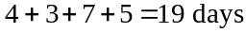.
(1 mark)

f. Activity B had a float time of 3 days. It now becomes a critical activity and extends the shortest time possible to set up the infrastructure by 1 day. It will now take 20 days.
(1 mark)
Total 15 marks

Module 6: Matrices

Question 1

- The order of M is .
(1 mark)

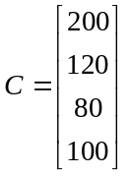

(1 mark)
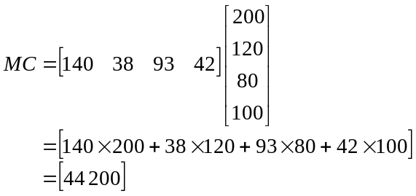

(1 mark)

- The matrix product MC represents the revenue for the gym made in a month from membership fees.
(1 mark)

Question 2

- 3 guest passes were sold last month for mainstream zumba classes.
(1 mark)

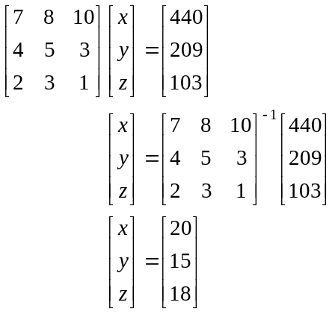

(1 mark)

The cost of a guest pass to a cardio class is $20, to a jump class is $15 and to a zumba class is $18.
(1 mark)

Question 3

- 30% of people change each week from a lunchtime class to an evening class.
(1 mark)

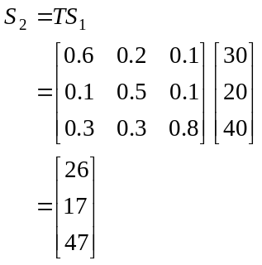

There will be 47 people in the evening yoga class in week 2.
(1 mark)
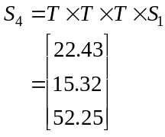

There will be 15 people (to the nearest whole number) in the lunchtime class in week 4.
(1 mark)

- We are looking at the long term so we see if we can find a steady state.
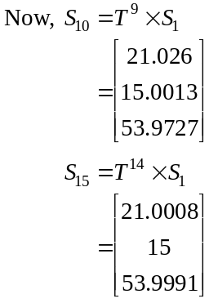
Correct to 1 decimal place a steady state has been reached.
Over the long term, the minimum class size is 15 so no classes will be discontinued.
(1 mark) finding a steady state
(1 mark) – answering the question

Question 4

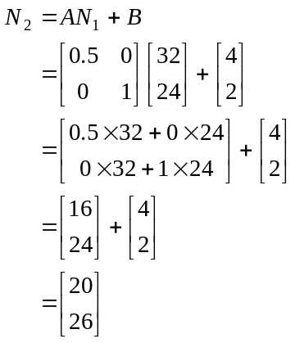

(1 mark)

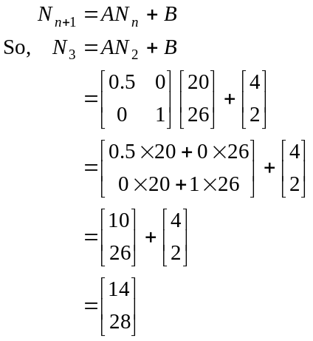

(1 mark)

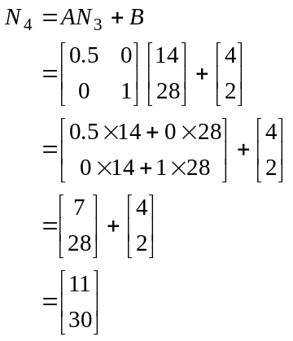
The difference in the size of the two classes in week 4 is 19.

(1 mark)
Total 15 marks

